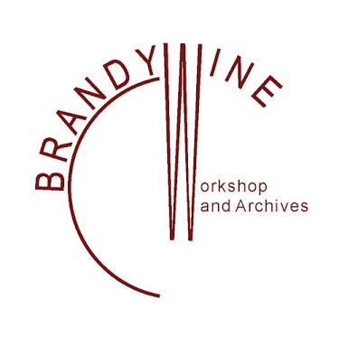
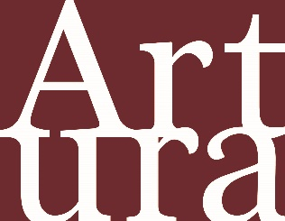

PRESS RELEASE

Date: October 2, 2021

PHILADELPHIA, PA—The Andrew W. Mellon Foundation has awarded the Brandywine Workshop and Archives (BWA) a major, two-year grant to advance its work in developing and sharing Artura.org, a free database of contemporary diverse art and artists that includes a digital image library and archives of over 1,400 prints and works on paper in its permanent collection and related educational resources. The $500,000 grant will fund a collaborative effort between BWA and Drexel University’s School of Education, Westphal College of Media Arts & Design, and its Arts Administration & Museum Leadership graduate program, with management support from Drexel’s Lenfest Center for Cultural Partnerships.

The grant will support work and staffing required to increase the scale of Artura.org in regard to expanded features, quality of content, user experience, and audience growth. The targeted audiences are: university professors, educators and students (K-12), artists, art historians-curators, and those among the general public who wish to explore the world and its many and diverse cultures through the visual arts. Artists from minority communities often are inspired by personal experience, history, and heritage, which are too often based in conflict. They reflect their perspectives through social narratives and religious beliefs represented in their artwork (i.e., John T. Scott, Juan Sanchez, Benny Andrews, Arturo Lindsay, Edgar Heap of Birds, Jacob Landau, and Belkis Ayon).

Key current and pending projects funded by the grant include the production of video interviews with artists with work featured in the database, digitizing artwork images, and formatting and creating documentation and interpretive materials for collections of works of art from printmaking organizations that, like BWA, are diversity driven. These include the Robert Blackburn Printmaking Workshop Collection, New York City; Self Help Graphics & Art, Los Angeles; Coronado Print Studios/Serie Project, Austin, TX; and Taller Experimental de Gráfica/Experimental Graphic Studio, Havana, Cuba.

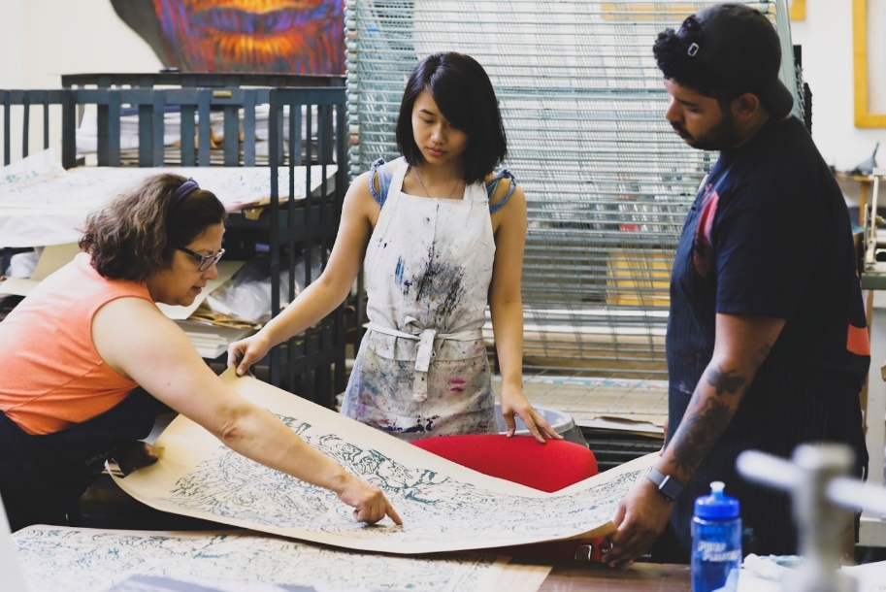

L-R: Visiting Artist Marta Sanchez works with college interns.

The Mellon Foundation’s generous support strengthens an operational foundation undergirding the full breadth of Artura’s offerings through 2023. Additionally, upcoming highlights for 2022 include two exhibitions now being organized with funding from the National Endowment for the Arts. All My Ancestors: The Spiritual in Afro-Latinx Art, curated by Tatiana Reinoza, PhD, Assistant Professor in Art History and Latin Studies at the University of Notre Dame, will be presented in winter 2022 on Artura.org and in person at BWA’s Printed Image Gallery; and Contemporary Printmaking in the African Disapora, curated by Anna Arabindan-Kesson, PhD, Assistant Professor of African American Art at Princeton University, will premier in fall 2022. These programs and ongoing activities provide new research and insight into the role of art in building communities and sharing across cultures, all of which will be easily accessible in the digital format of Artura.

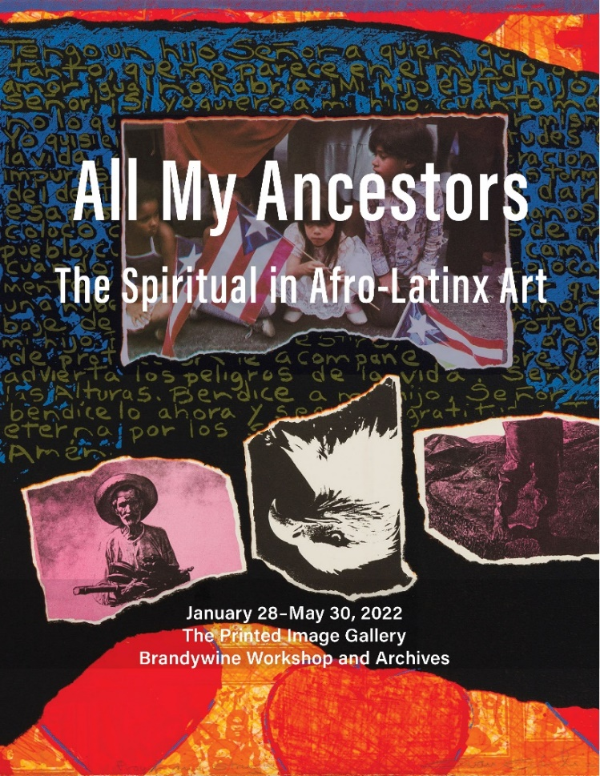

Making Artura.org an extraordinary and excellent resource is the wide diversity of heritage, race, ethnicity, gender, and other aspects of intersectional identity represented by its artists and their art; depth of documentation; and the authenticity of the information and resources it provides, which is a product of working closely and collaboratively with artists throughout BWA’s five-decade history. Original artworks produced by BWA with visiting artists have been acquired through 16 Satellite Collections at art museums, universities, and heritage centers across the country, including Arizona State University, University of Texas-Austin, Hamoton University Museum, Rhode Island School of Design Museum, Harvard University Museums, Museum of Contemporary Native Arts, Schomburg Center for Research in Black Culture, Hampton University Museum, and others. In addition, hosting artists from around the world, past cultural collaborations and exchanges with the Cardiff School of Art & Design, Wales, UK, and Havana, Cuba’s Taller Experimental de Gráfica, BWA has established an international imprint and reach. To date, prints made by BWA visiting artists have traveled in exhibitions to more than 30 states and 35 cities abroad.

Two dozen museum and education professionals representing BWA’s Satellite Collections partner organizations and others serve on the Institute for Inclusion, Diversity, and Equity in Education and the Arts (IIDEEA). Organized by BWA in 2018 as a virtual entity to advise and serve as a working group composed of experts and seasoned veterans who contribute content, provide technological expertise, and develop educational resources that answer critical needs in diversifying and enhancing the canon of American art and education curriculum.

The ambitious and essential goals of BWA-IIDEAA are being realized through the development of its first project, Artura.org, launched in March 2020. Artura taps into the institutional capacity and interests of professors such as Neville Vakharia, Jennifer Katz-Buonincontro, Julie Goodman, and Brea Heidelberg at Drexel University, and others, including Chief Investigators Richard Siegesmund, professor emeritus at Northern Illinois University, and assistant professor Reinoza. Allan Edmunds, executive director at BWA, and Drexel University’s Rosalind Remer, Senior Vice Provost for University Collections and Exhibitions and Executive Director of the Lenfest Center for Cultural Partnerships, are the Artura.org grant project’s administrators-in-charge.

In addition to advancing the content and features of Artura.org and adding new artists and new collections from other arts groups, the mobile-compatible platform design—developed by John Cardone of Being Design, Scottsdale, AZ—is engineered to maximize the user experience. To further share and promote Artura.org’s services, BWA has been partnering with organizations such as the Print Council of America, Association of Print Scholars, National Art Education Association, and other affinity groups in presenting webinars and other promotional activities.

This unprecedented collaboration by diverse organizations and individuals is not a response to changes demanded by relatively recent protests but, rather, the product of BWA’s overarching, five-decades-long commitment to diversity, artistic excellence, education, and free public access that is wide geographically and makes proactive use of evolving technology.

After a half century of collaborative work with artists at various stages of their careers—among them Betye and Alison Saar, Jacob and Gwen Lawrence, Deborah and Hank Willis, Willie Cole, El Anatsui, Elizabeth Catlett, Richard Hunt, Jules Olitski, Diedrick Brackens, Barbara Chase-Riboud, and many other word-class artists—Artura.org is a living, growing resource that preserves and shares a legacy of achievement too-long hidden, a portal for future excellence in multicultural creativity and education, and a pathway toward a more humane society and global engagement.

For more information and photographs, please contact:

Allan L. Edmunds, Brandywine Workshop and Archives
Cell: 267.258.3558 Ofc: 267.831.2928
Email: aedmunds@brandywineworkshop.com

Rosalind Remer, Drexel University Lenfest Center for Cultural Partnerships
Phone: 215.895.1203
Email: Rosalind.Remer@drexel.edu

